**Exp. No : 4**

# User Defined Function (UDF) in PIG

1. Create sample.txt

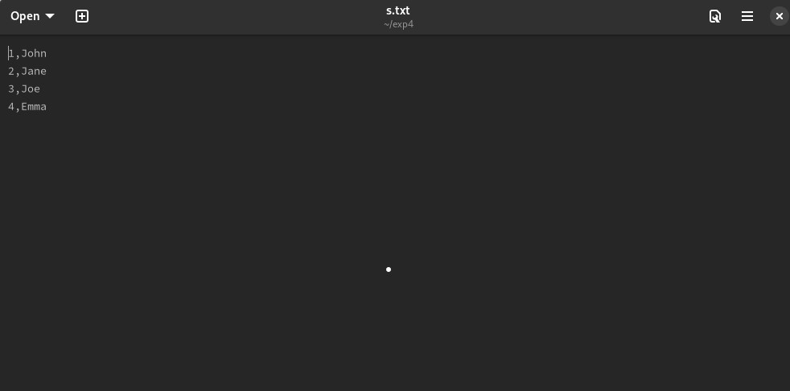

1. Create demo_pig.pig file

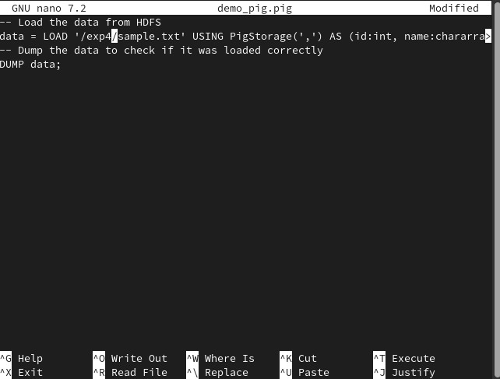

1. 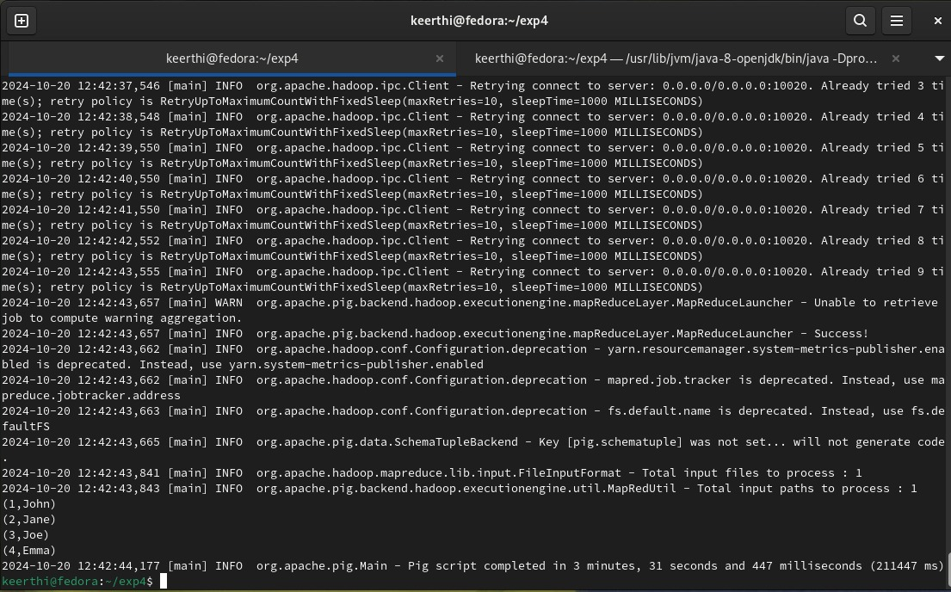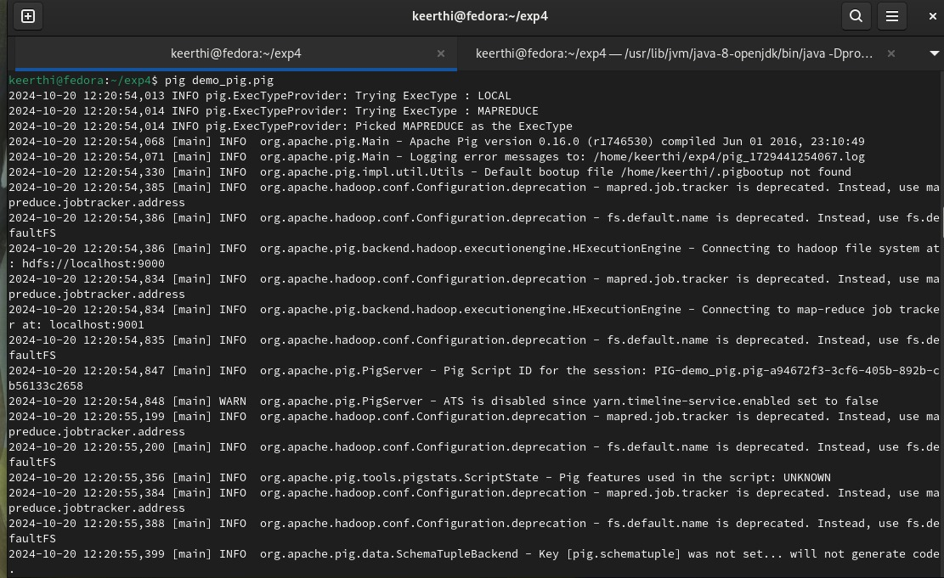Execute demo_pig.pig

1. Create uppercase_udf.py

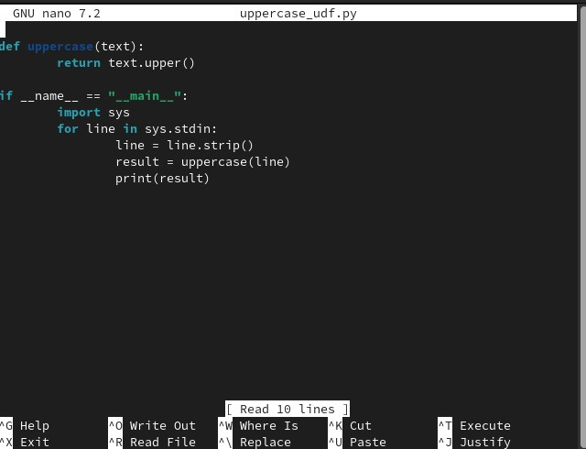

5.Create udf_example.pig

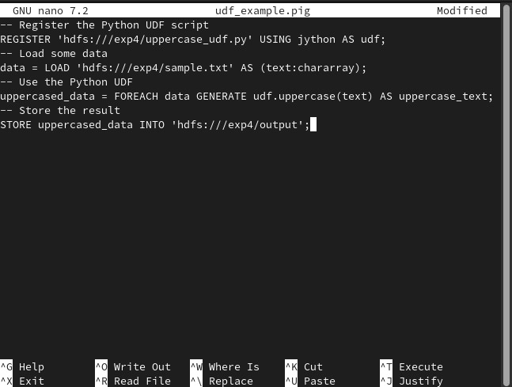

1. Execute udf_example.pig

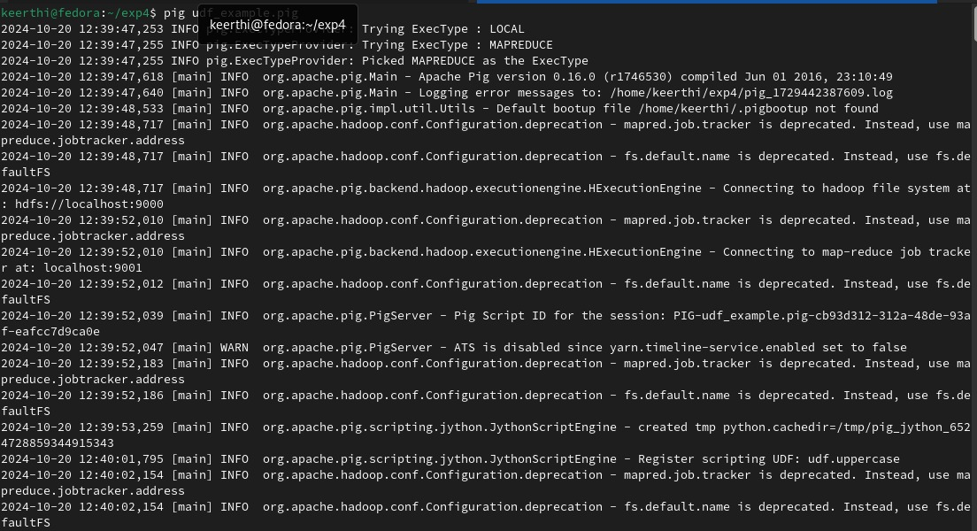

**Output :**

